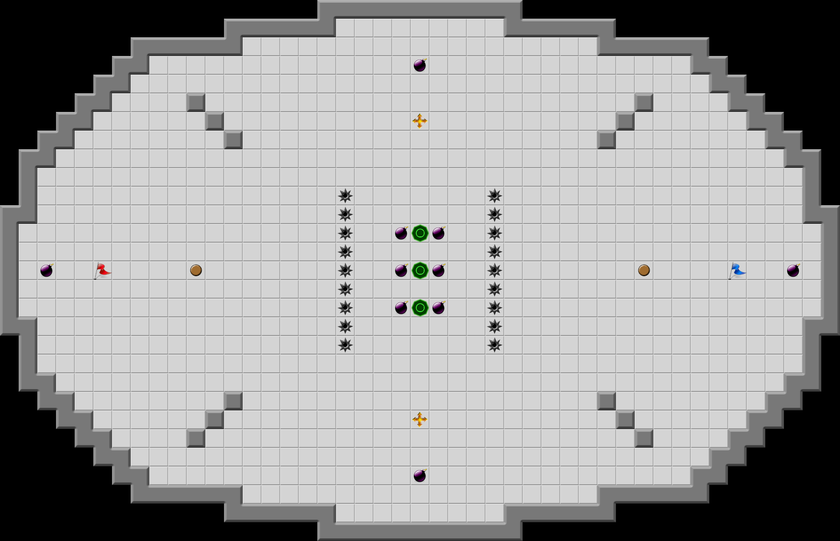
TAG

Overview
Move around a 2D map trying to tag enemies and avoid getting tagged. If you’re it, you will lose health. When you’re health hits 0, you’re dead.
The basic idea came from the popular browser game Tag Pro.

Basic Rules
- Move around using a joystick.
- One player/AI randomly begins as “it”.
- Each player will start with a timer, similar to health. While being “it”, their remaining time will decrease. If they are “it” for too long, they lose.
- Collisions with other players/AI affects their trajectory.
- Obstacles will be present, potentially dangerous. Walls can block a player’s movement and mines will penalize them.
- There will be different pre-designed maps to play on.

Features
- Possible game-modes: Reverse Hot-Potato, Maze Race, King of the Hill
- Slide pots/ joystick can be used with an ADC to control horizontal and vertical movement.
- Button is used for power up deployment.
- Timer triggered sound interrupts.
- Power Ups/Downs: Power-ups can spawn at certain points on the map. Here are some of the possible effects.
- Speed up – Increase speed.
- Slow down – Decrease speed.
- Time up – Increase remaining time (health).
- Tag shield – Tag immunity.

Difficulty
Depending on the variations you add to the game, this could be a hard game given the following items.
- Physics engine involved.
- Control of speed/frame rate.
- Well-optimized map drawings.
- AI effectiveness.
- UART multiplayer capabilities.
- Multiple game modes.

